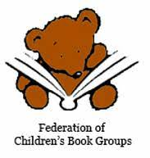
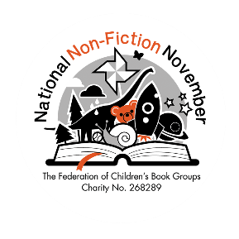
National Non-fiction November
Competition

National Non-Fiction November is the Federation of Children’s Book Groups’ annual celebration of all things factual.
The theme this year is ‘Wonderful Water’, and our competition has been inspired by ‘Sea Change: Save the Ocean’, edited by Tobias Hickey of the International Centre for the Picture Book in Society at Worcester University. Published by Otter-Barry Books, this is a collection of original postcards and messages from 50 illustrators across the world, working to celebrate and protect the precious life in our oceans.
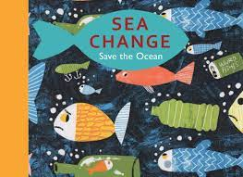
To enter, children are invited to create their own postcard. On one side, they should create (paint/ draw/ collage/ print etc) a picture of their favourite watery location and then on the reverse, write about why this place is so important to them.
There are three age group categories:
5-7 (30-40 words)
8-10 (40-60 words)
11-12 (60-100 words)
Each will be judged on their originality, creativity and presentation, according to age.
Please send entries to Sea Change Competition, 123 Frederick Road, Cheam, Sutton, SM1 2HT or email to nnfn@fcbg.org.uk Closing date: Monday 4th December 2023

