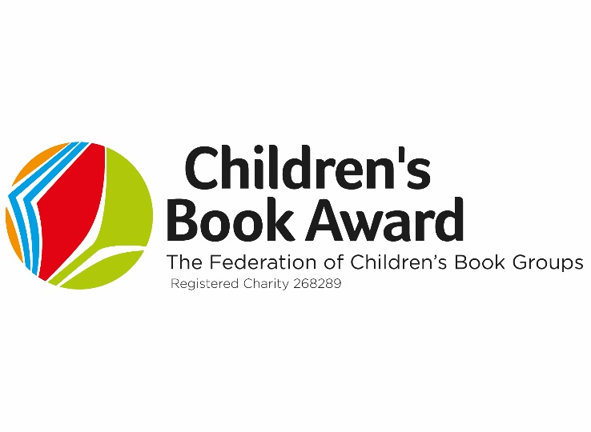
All Winners 1981-2022

Year | Author | Illustrator | Title | Publisher
1981 | Quentin Blake | Quentin Blake | Mr Magnolia | Jonathan Cape
1982 | Leon Garfield | Brian Hoskin | Fair’s Fair | Macdonald Young Books
1983 | Roald Dahl | Quentin Blake | The BFG | Jonathan Cape
1984 | Terry Jones | Michael Foreman | The Saga of Erik The Viking | Pavilion
1985 | Robert Swindells |  | Brother In The Land | O U P
1986 | Amanda Graham | Donna Gynell | Arthur | Spindlewood
1987 | J. & A. Ahlberg | Janet Ahlberg | The Jolly Postman | Heinemann
1988 | Valerie Thomas | Korky Paul | Winnie the Witch | O U P
1989 | Roald Dahl | Quentin Blake | Matilda | Jonathan Cape
1990 | Robert Swindells |  | Room 13 | Doubleday
1991 | Mick Inkpen | Mick Inkpen | Threadbear | Hodder & Stoughton
1992 | Elizabeth Laird |  | Kiss the Dust | Methuen
1993 | J.Wilson | Nick Sharratt | The Suitcase Kid | Heinemann
1994 | Ian Strachan |  | The Boy In the Bubble | Methuen
1995 | Dick King-Smith |  | Harriet’s Hare | Doubleday
1996 | J.Wilson | Nick Sharratt | Double Act | Doubleday
1997 | J. Strong | Nick Sharratt | The Hundred-Mile-An-Hour Dog | Viking
1988 | J. K. Rowling |  | Harry Potter and The Philiosopher’s Stone | Bloomsbury
1999 | J. K. Rowling |  | Harry Potter and The Chamber of Secrets | Bloomsbury

Year | Author | Illustrator | Title | Original Publisher
2000 | M. Morpurgo | Michael Foreman | Kensuke’s Kingdom | Heinemann
2001 | Kes Gray | Nick Sharratt | Eat Your Peas | The Bodley Head
2002 | Malorie Blackman |  | Noughts & Crosses | Corgi
2003 | A. Horowitz |  | Skeleton Key | Walker
2004 | M. Morpurgo | Michael Foreman | Private Peaceful | Harper Collins
2005 | Simon James | Simon James | Baby Brains | Walker
2006 | Rick Riordan |  | The Lightning Thief | Puffin (UK)
2007 | Andy Stanton | David Tazzyman | You’re A Bad Man Mr Gum! | Egmont
2008 | Derek Landy |  | Skulduggery Pleasant | Harper Collins
2009 | Sophie McKenzie |  | Blood Ties | Simon & Schuster
2010 | Suzanne Collins |  | The Hunger Games | Scholastic
2011 | M. Morpurgo | Michael Foreman | Shadow | Harper Collins
2012 | Patrick Ness | Jim Kay | A Monster Calls | Walker
2013 | Andrew Weale | Lee Wildish | Spooky Spooky House | Corgi
2014 | Rick Yancey |  | The 5th Wave | Penguin
2015 | Drew Daywalt | Oliver Jeffers | The day The Crayons Quit | Harper Collins
2016 | Pamela Butchart | Thomas Flintham | My Head Teacher Is A Vampire Rat | Nosy Crow
2017 | M. Morpurgo | Michael Foreman | Eagle In The Snow | Harper Collins
2018 | Katherine Rundell |  | The Explorer | Bloomsbury
2019 | Aree Chung | Aree Chung | Mixed | Macmillan
2020 | Tom Palmer |  | D-Day Dog | Barrington Stoke
2022 | Peter Bently | Steven Lenton | Octopus Shocktopus! | Nosy Crow
2023 | Louie Stowell |  | The Bad God’s Guide to Being Good | Walker

