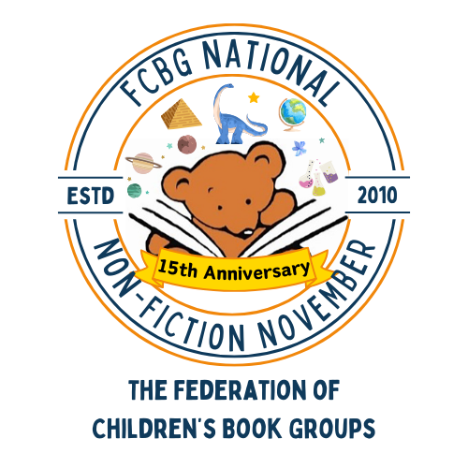

National Nonfiction November Competition Entry Form - Individual Entry

PLEASE MAKE SURE YOU ATTACH THIS FORM TO YOUR EMAIL OR YOUR POSTAL ENTRY. If there is no form, your entry may not count.
This form is for individual entries, please use the alternative form if you are a class teacher or submitting multiple entries for different aged children.

Name of Child and Age
Topic of Entry
Entry category - tick one | - Age 5-7  - Age 8-10  - Age 11-16
Parent Name
Address - block capitals please! (include postcode)
Consent to enter the competition (Please see the Terms and Conditions on the FCBG Website | Sign Here

