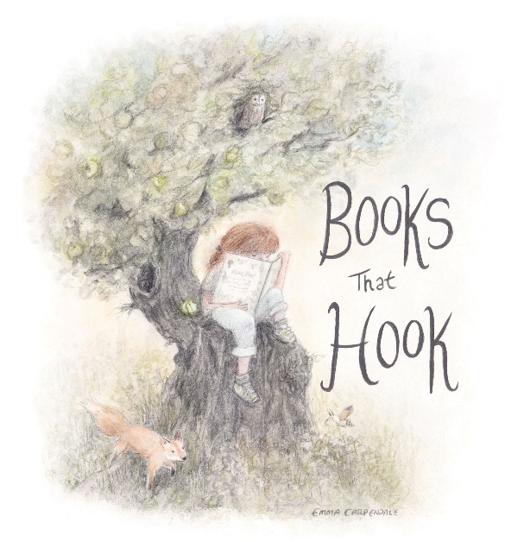

FCBG Annual Conference
Leighton Park School Reading
10th to 12th April 2026
FRIDAY
15:30 Registration
16:00 - 16:30 Isadora Moon 10th anniversary tea
16:30 - 17:50 Publishers’ Exhibition in the Exam Centre
18:00 - 19:00 Dinner
19:00 – 19:20 Drinks with Bloomsbury and Kate Pankhurst
19:20 – 20.20 Crime and mystery panel with Holly Webb, J J Arcanjo, Sufiya Ahmed
20:25 - 21:10 TBC possibly Ed Vere plus

SATURDAY
7:30 - 8:30 Breakfast
8:30 - 8:45 Day Delegate Registration
8:45 - 9:15 FCBG AGM
9:20 - 10:00 Accessible books panel with Barrington Stoke and Every Cherry
10:00 - 10:45 Reaching reluctant readers with Philip Kavvadias and Phil Earle
10:45 - 11:15 Otter Barry 10th anniversary coffee break
11:15 - 12:15 Verse Novels with Sarah Crossan, Tia Fisher, Ella McLeod
12:20 - 13:00 Illustrating classics with Chris Mould
13:00 - 14:10 Lunch and Exhibition
14:10 - 14:55 TBC
15:00 - 16:00 CBA Panel with Ross Montgomery, Malcolm Duffy, Leonie Lord
16:00 - 16:30 Jolly Postman 40th anniversary tea
16:30 - 17:30 Meetings
18:30 – 19:00 Little People Big Dreams 10th anniversary drinks
19:00 Gala Dinner with Sophie Anderson

SUNDAY
7:30 - 8:30 Breakfast
8:30 - 9:00 Day delegate registration
9:00 - 9:40 TBC
9:45 - 10:45 Non-fiction panel with Susan Martineau, Leigh Hodgkinson, Samantha Lewis
10:45 - 11:15 Nosy Crow 15th anniversary coffee break
11:15 - 12:15 Graphic novels for younger readers with Jon Lock, Nich Angel, Cat Weldon, Nene Lonergan
12:20 - 13:00 A. F. Harrold
13:00 – 14:00 Lunch
Please note all sessions subject to change

