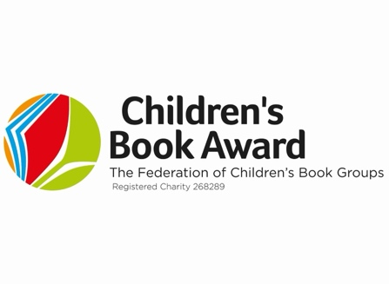
EMBARGOED UNTIL 3PM, SATURDAY 13TH JUNE 2026

Winners Announced for the 2026 FCBG Children’s Book Award
The Federation of Children’s Book Groups is delighted to announce the winners of the 2026 Children’s Book Award, the only national book award voted for entirely by children.
Now celebrating its 46th year, the Children’s Book Award continues to shine a spotlight on the books that truly connect with young readers, with children across the UK choosing the stories that captured their imaginations, hearts and conversations over the past year.
This year’s winners are:
Books for Younger Children:
Gozzle by Julia Donaldson and Sara Ogilvie (Macmillan Children’s Books)
Books for Younger Readers and Overall Winner:
Pablo and Splash: Roman Holiday by Sheena Dempsey (Bloomsbury Children’s Books)
Books for Older Readers:
My Name is Samim by Fidan Meikle (Floris Books)
Sheena Dempsey’s Pablo and Splash: Roman Holiday was not only voted winner in the Younger Readers category but also crowned the Overall Winner of the 2026 Children’s Book Award. Bursting with humour, comic chaos and vibrant illustrations, the latest adventure in the much-loved series proved enormously popular with children across the country.
The success of Pablo and Splash also reflects the continuing rise in popularity of graphic novels and illustrated fiction amongst young readers. Dynamic, accessible and highly engaging, graphic storytelling is playing an increasingly important role in fostering a love of reading and helping children build reading confidence and enjoyment.
Beloved author Julia Donaldson adds another accolade to her distinguished career with Gozzle, a charming and memorable story that proved hugely popular with the youngest children. Continuing a successful partnership, Sara Ogilvie’s quirky illustrations add extra details to the humour and warmth of Donaldson’s trademark storytelling magic.
Meanwhile, My Name is Samim by Fidan Meikle was voted favourite in the Older Readers category. This powerful and thought-provoking debut novel resonated deeply with readers through its moving exploration of identity, belonging and resilience, highlighting the ability of children’s books to open conversations and foster empathy.
Sarah Stuffins, CBA Coordinator says: “This year once again saw an outstanding response from young readers, with thousands of children taking part in the voting process. The continued enthusiasm for the award demonstrates the importance of giving children ownership over the stories they read and celebrate. This year’s winners reflect a fascinating cross-section of children’s books: a hilarious time-travel adventure story in graphic novel format, a heart-warming family story from a popular author/illustrator duo, and a thought-provoking debut about migration.”
The Federation of Children’s Book Groups would like to congratulate all of this year’s shortlisted authors and illustrators, whose books inspired such excitement and passion among young readers across the country. The winners will officially receive their awards at a special ceremony in Birmingham on Saturday 13th June 2026, where children will once again remain at the very heart of the celebrations. Reflecting the truly child-centred nature of the award, young readers themselves will present the trophies to the winning authors and illustrators, celebrating the books they have loved most throughout the year.

Notes to Editors:
The Children’s Book Award was founded in 1980 by the national children’s reading charity, the Federation of Children’s Book Groups. It is the only national UK children’s book award to be voted for entirely by children and each year over 80,000 votes are cast, involving nearly 250 schools across the UK. The ten titles on the shortlist for the Books for Younger Children, Books for Younger Readers and Books for Older Readers categories, were chosen by children nationwide who read and voted for the books throughout the year as part of the network of the Federation’s Children’s Book Groups.

The Federation of Children’s Book Groups was set up as a charity in 1968 by Anne Wood, the Founder and Creator of Ragdoll Productions and the originator of The Teletubbies. It acts as an umbrella organisation for local Children’s Book Groups all over the UK. The groups organise a variety of activities including author events and other activities that promote the enjoyment of children’s books. The Federation also produces numerous specialist book lists, organises National Share-a-Story Month each May, National Non-Fiction November and holds an annual conference each spring.

For further information or interview requests, please contact:
Sarah Stuffins
Children’s Book Award Coordinator
childrensbookaward@fcbg.org.uk

https://fcbg.org.uk/cba-home/
https://www.facebook.com/fcbgnews
https://www.instagram.com/fcbg_news/

#FCBGCBA26

