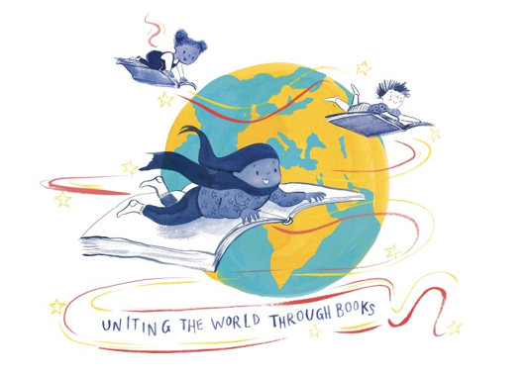
FCBG Annual Conference
Culford School, Bury St Edmunds
9th to 11th April 2027
FRIDAY
15:00 Registration
15:30 - 16:15 Tea break celebrating 25 years of Bounce Marketing and welcome from Ipswich Children’s Book Group and Jonathan Stroud
16:15 - 17:45 Publishers’ Exhibition
18:00 - 19:00 Dinner
19:15 - 20.00 Drinks and speaker TBC
20:00 - James Mayhew and Caroline Clarke
20:30 - Bar

SATURDAY
7:30 - 8:30 Breakfast
8:30 - 8:45 Day Delegate Registration
8:45 - 9:15 FCBG AGM
9:20 - 10:00 Mel Taylor-Bessent and Jennifer Bell
10:00 - 10:45 Ian Eagleton
10:45 - 11:15 DK Pop Up coffee break
11:15 - 12:15 Diversity in Publishing Panel TBC
12:15 - 13:00 Federation Gift Presentation and Publishers Exhibition
13:00 - 14:00 Lunch
14:00 - 14:45 Kate Rolfe
14:45 - 15:45 Myths Panel with Clare Pollard, Denzell Dankwah, Cairo Aibangbee
16:00 - 16:30 Tea Break celebrating 120 years of OUP
16:30 - 17:30 Meetings
18:30 - 19:00 Malory Tower drinks with Fleur Hitchcock and Hachette
19:00 Gala Dinner with Kate Wilson
21:30 - Bar

SUNDAY
7:30 - 8:30 Breakfast
8:30 - 9:00 Day delegate registration
9:00 - 10:00 Writing for Tweens: Clean Teen Panel with Tamsin Winter, Nat Luurtsema, Emma Shevah
10:00 - 10:45 Margaret McDonald
10:45 - 11:15 Coffee Break with Usborne and Nat Luurtsema
11:15 - 12:15 Panel TBC
12:15 - 13:00 Maz Evans
13:00 Close of conference
13:00 – 14:00 Lunch

Please note all sessions subject to change

