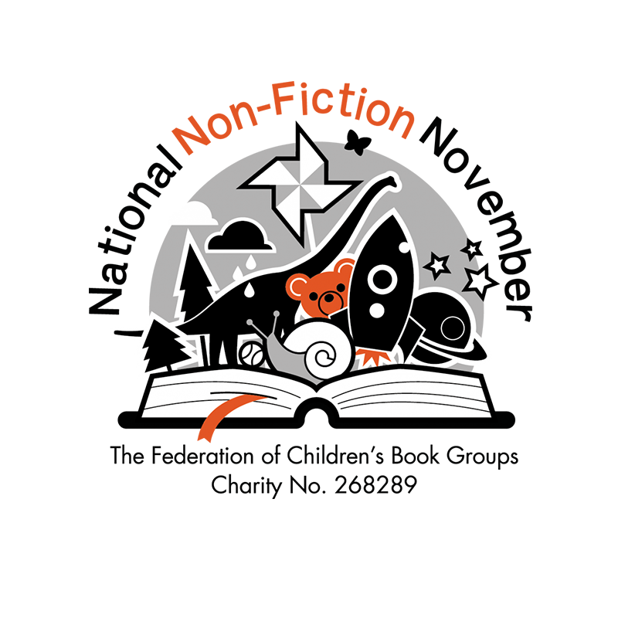

National Non-Fiction November Competition Entry Form - Class or Group Entry

PLEASE MAKE SURE YOU ATTACH THIS FORM TO YOUR EMAIL OR YOUR POSTAL ENTRY. If there is no form, your entry may not count. Video entries will need a consent form if a child is featured in the video, which can be obtained by contacting the NNFN email. Maximum 2 minutes long - anything longer will not be counted.
The file may need to be reduced in size before submission via email, or sent through WeTransfer. Contact nnfn@fcbg.org.uk for further information.

This form is for group or multiple entries, please use the alternative form for individual entries.
Please number your entries before writing them in the form and make sure the numbers are clearly on the piece that you send.

Class Name
Entry category - tick the ones that this form includes. | - Age 5-7  - Age 8-10  - Age 11-16
Teacher/Responsible Adult Name
Address - block capitals please! (include postcode)
Consent to enter the competition (Please see the Terms and Conditions on the FCBG Website) | Sign Here

Number on Entry  Eg. 1 | Child’s Name (age in Brackets) | Topic of Entry/Book Used | Age Category

Please note; We may not be able to send any entries back by post - it may be better to send them via email ; nnfn@fcbg.org.uk
Reminder; Videos must be less than 2 minutes long and have a consent form included which can be obtained by emailing the NNFN account.

POSTAL ENTRIES TO

J Brown
Brockhill Park Performing Arts College
Sandling Road
Saltwood
Hythe
Kent
CT214HL

