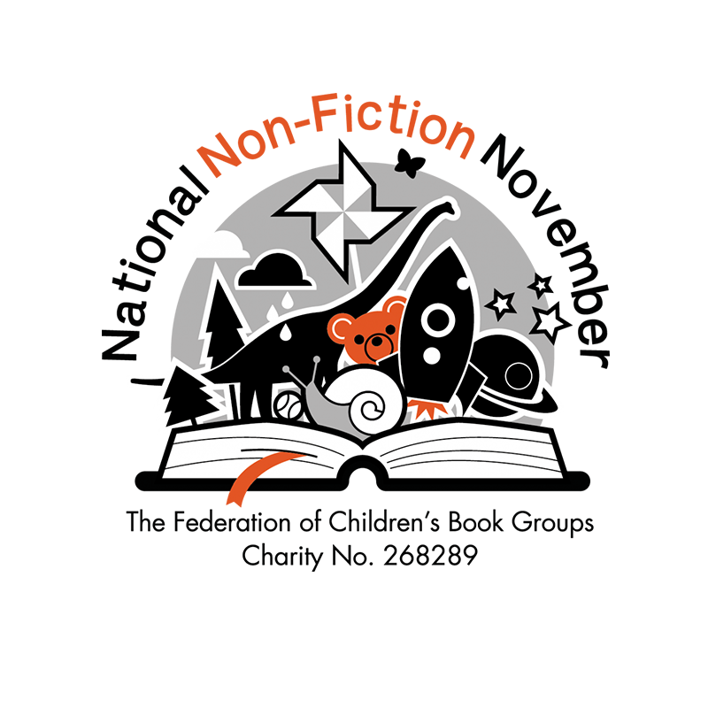

National Non-Fiction November Competition Entry Form - Individual Entry

PLEASE MAKE SURE YOU ATTACH THIS FORM TO YOUR EMAIL OR YOUR POSTAL ENTRY. If there is no form, your entry may not count. Video entries will need a consent form if a child is featured in the video, which can be obtained by contacting the NNFN email. Maximum 2 minutes long - anything longer will not be counted.
The file may need to be reduced in size before submission via email, or sent through WeTransfer. Contact nnfn@fcbg.org.uk for further information.
This form is for individual entries, please use the alternative form if you are a class teacher or submitting multiple entries for different aged children.

Name of Child and Age
Topic of Entry/Book Used
Entry category - tick one | - Age 5-7  - Age 8-10  - Age 11-16
Parent Name
Address - block capitals please! (include postcode)
Consent to enter the competition (Please see the Terms and Conditions on the FCBG Website | Sign Here
Postal Entries to:

J Brown
Brockhill Park Performing Arts College
Sandling Road
Saltwood
Hythe
Kent
CT214HL

